**Fase 2 Matta Sur**

**Referentes señalética e intervención en el espacio**

<https://www.elespectador.com/noticias/medio-ambiente/bikos-moneda-de-los-ciclistas-articulo-676994>

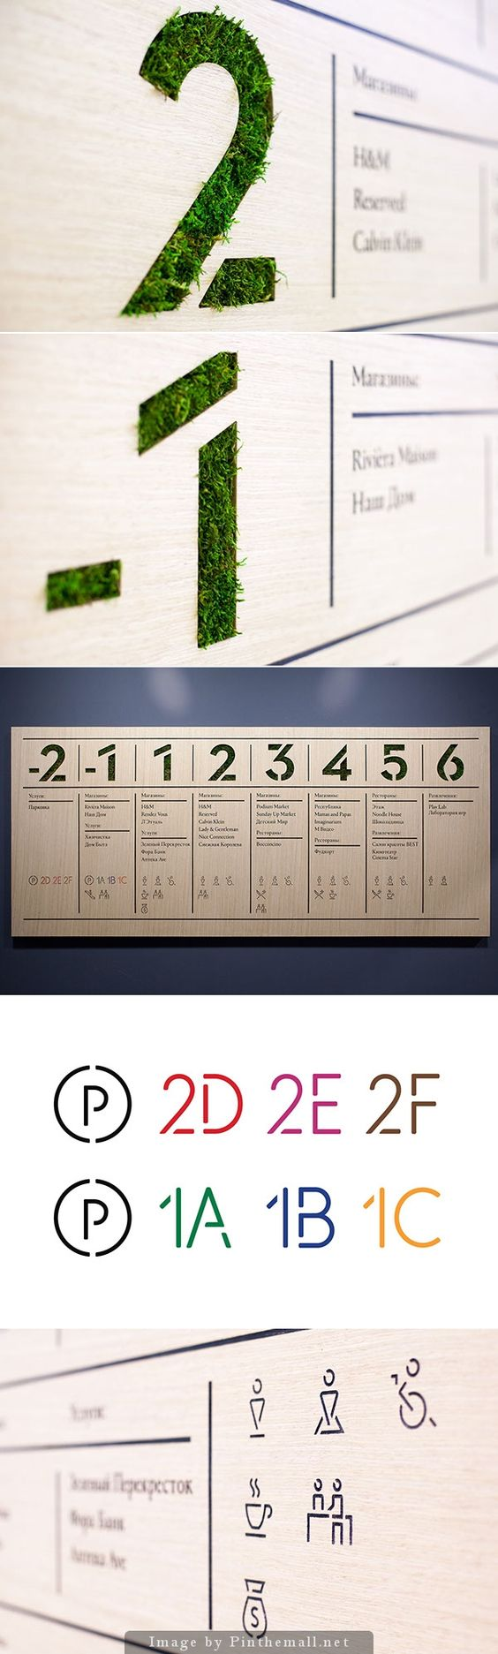

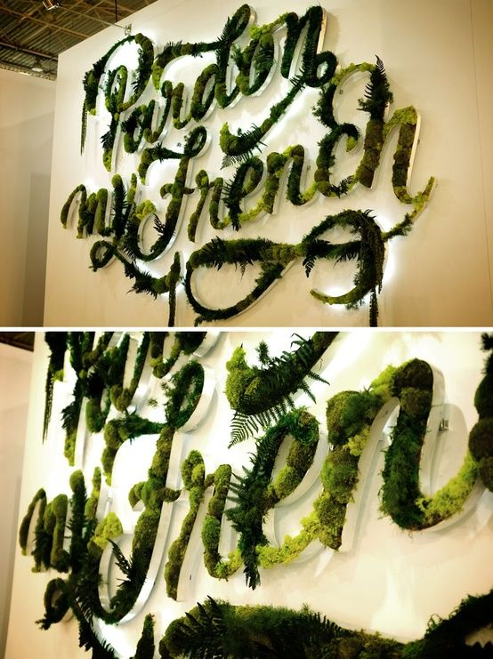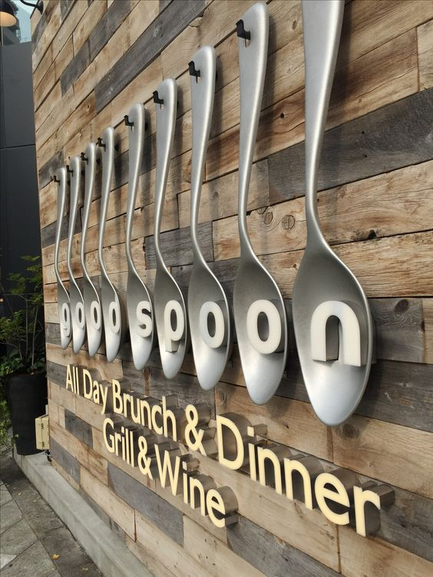

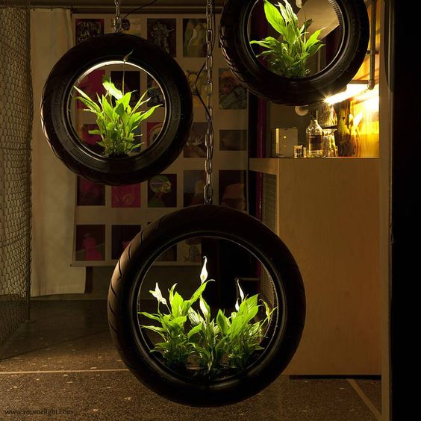

<https://www.pinterest.es/pin/720224165382162913/>

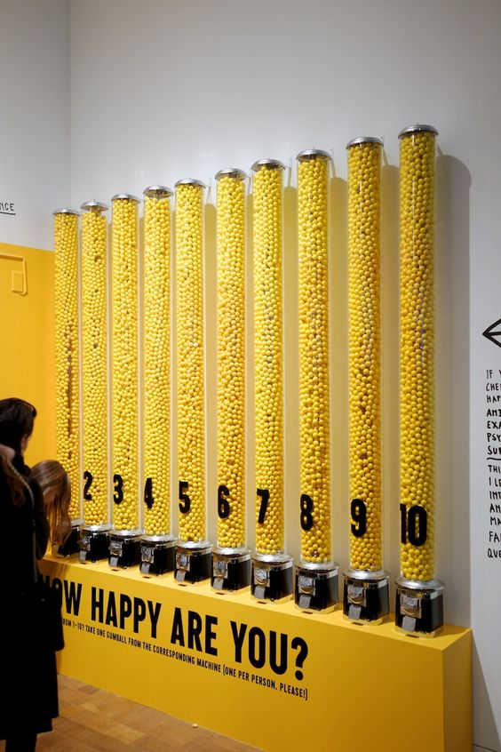

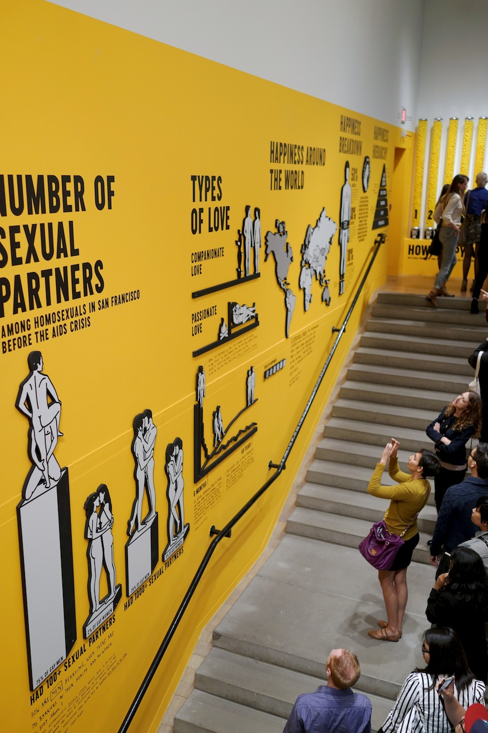

<http://www.minimallyminimal.com/blog/the-happy-show-at-moca>

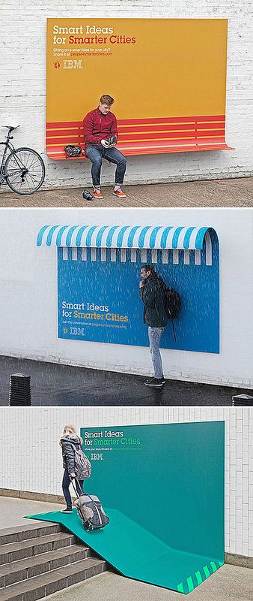

<https://www.flickr.com/photos/33519432@N04/9566501628/in/photostream/>

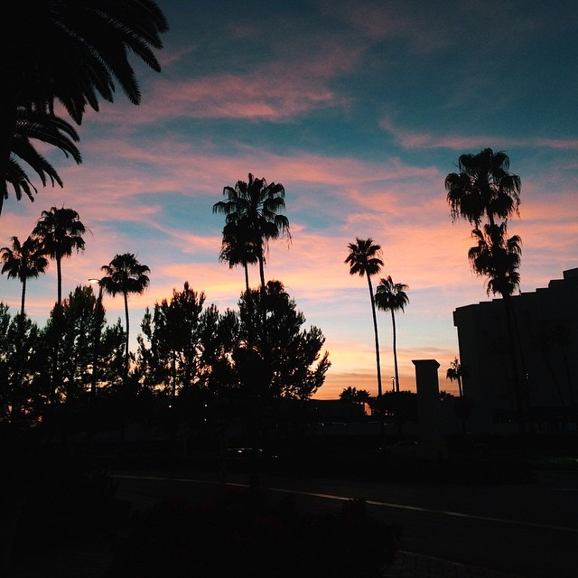

<http://one-tsuchikawa-drop.tumblr.com/> (Vender experienccias)

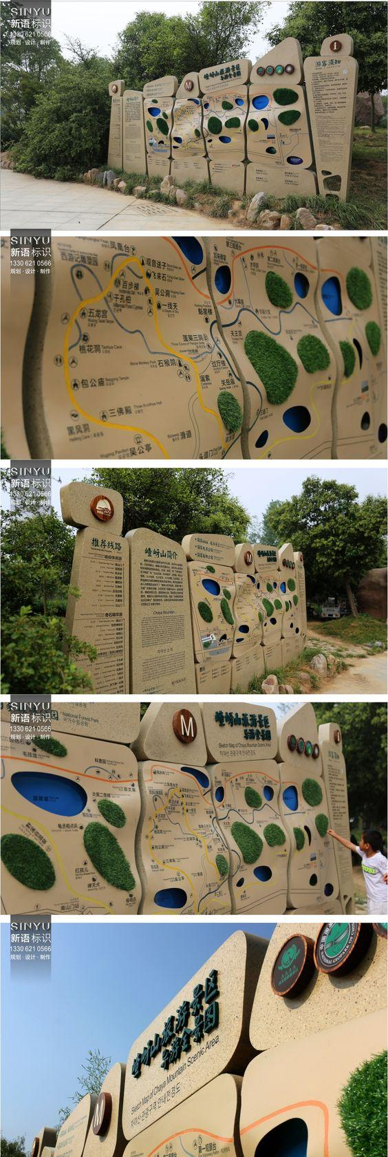

<http://sinyu.com.cn/caseShow.aspx?ProductsID=59&CateId=10>

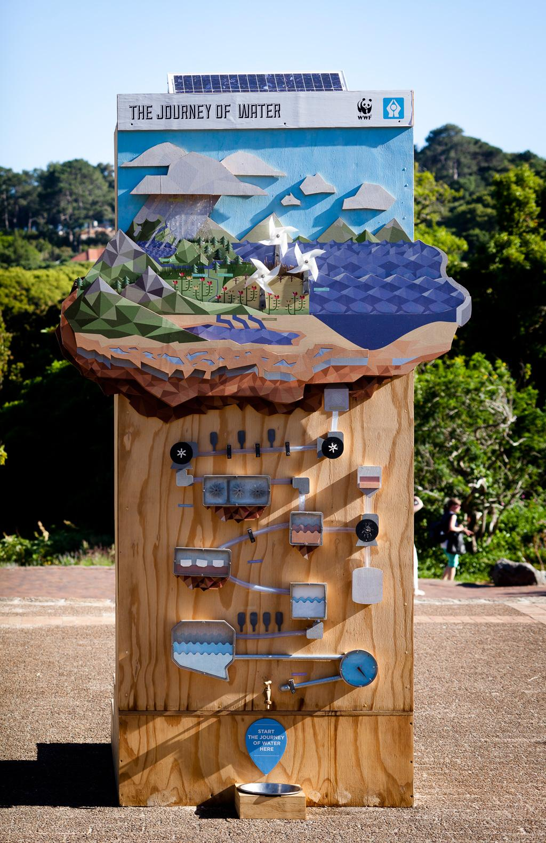

<https://www.visi.co.za/making-more-and-more/>

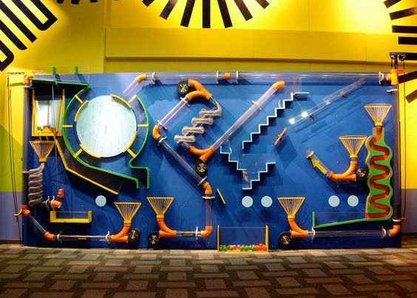

<http://www.bossdisplay.com/portfolio/ball-exhibits-view-more> (El más hermosooo e importante)

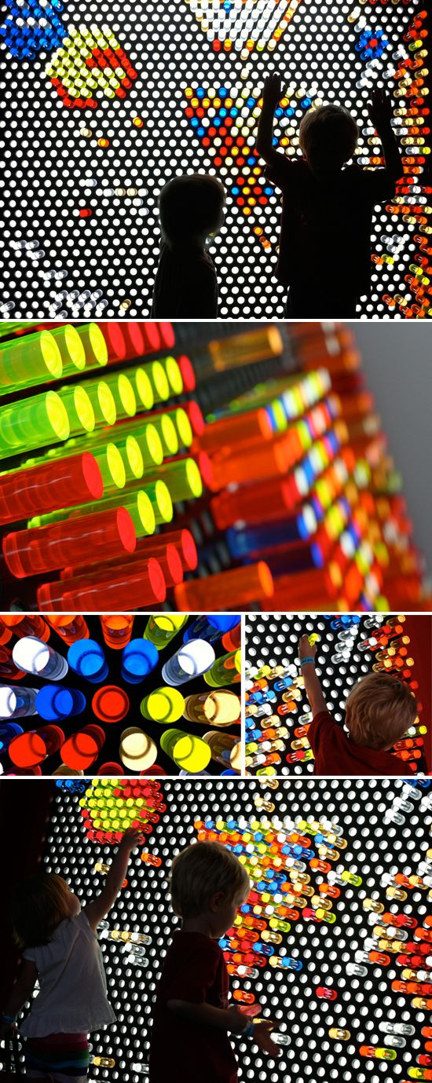

<http://www.warmhotchocolate.com/2010/09/21/lite-brite-super-sized/>

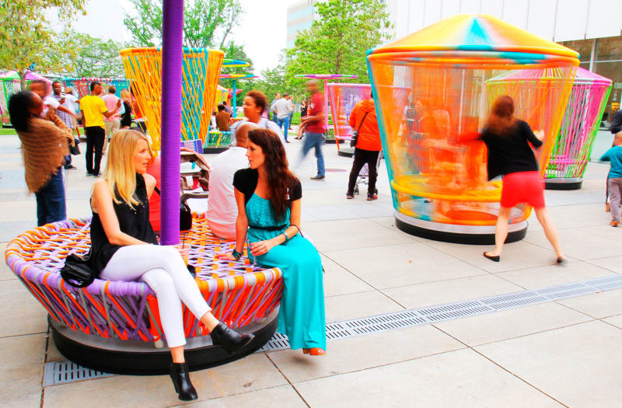

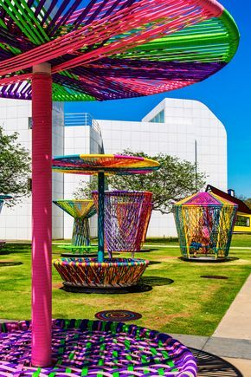

<https://divisare.com/projects/294244-H-ctor-Esrawe-Ignacio-Cadena-Los-Trompos>

(Este es increíblemente genial)

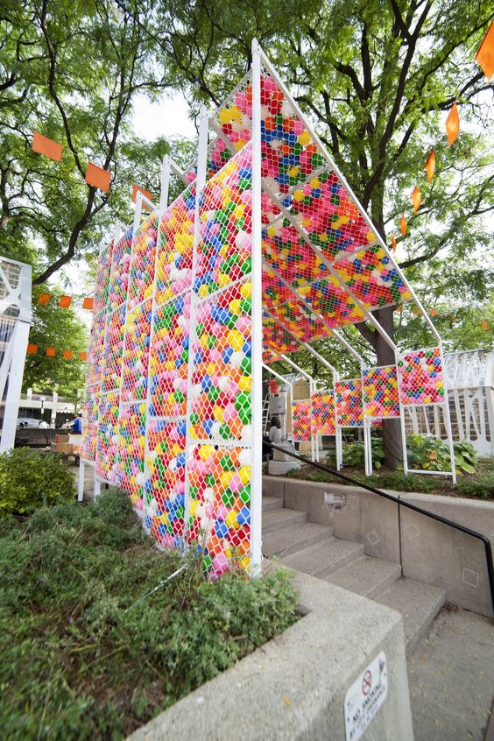

<https://archinect.com/synecdoche/project/water-pavilion?utm_content=bufferb82c3&utm_medium=social&utm_source=pinterest.com&utm_campaign=buffer>

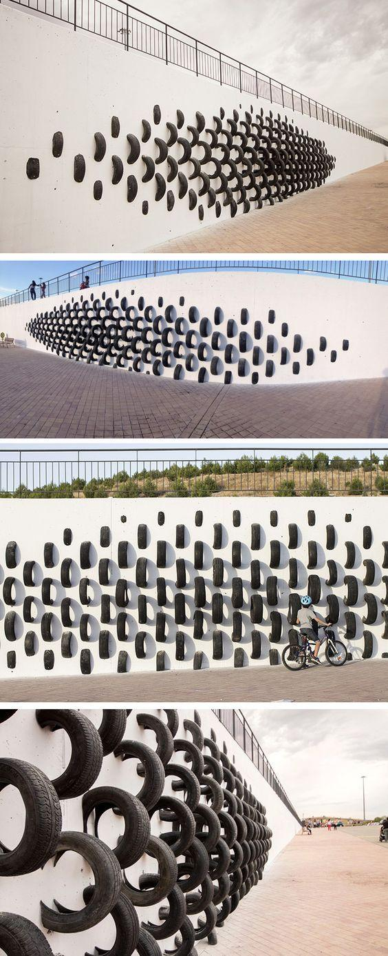

<http://www.contemporist.com/spanish-artists-use-old-tires-to-create-wall-art/>

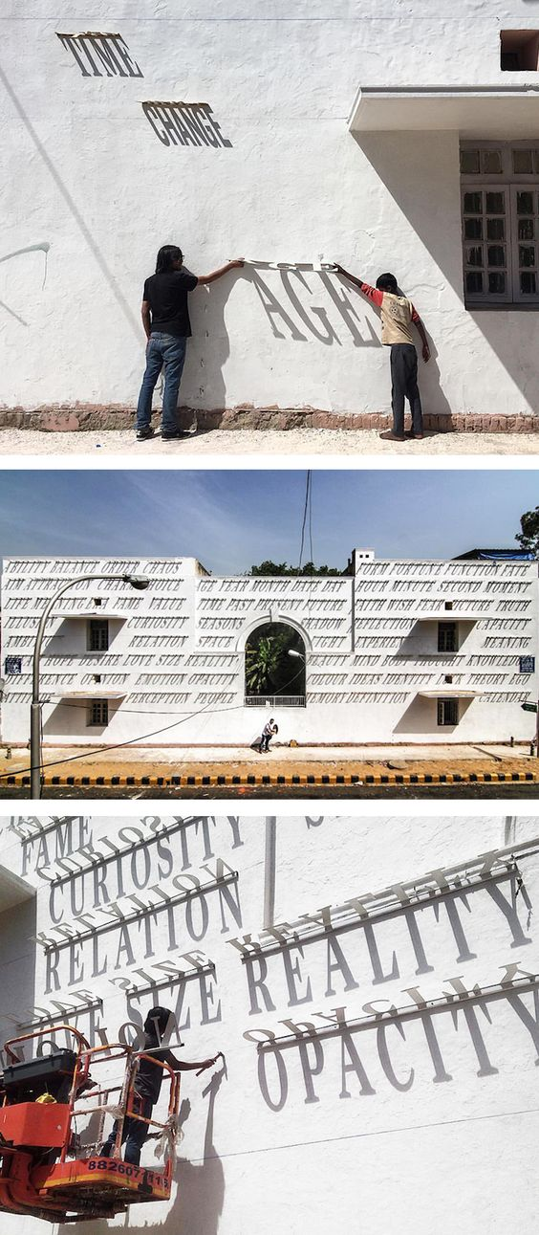

<https://mymodernmet.com/daku-sundials-innovative-graffiti/>

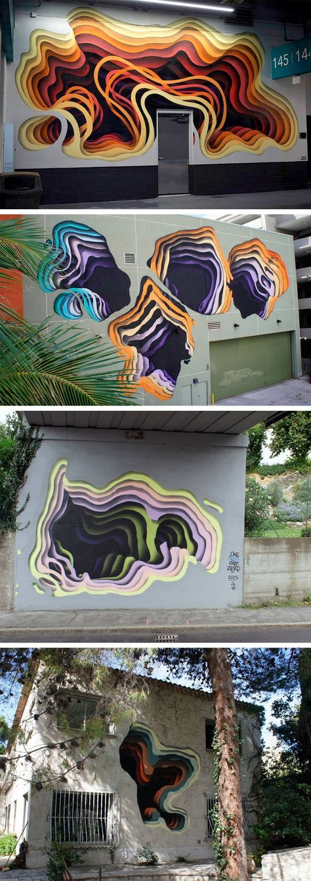

<https://www.thisiscolossal.com/2016/12/new-cavernous-murals-by-german-street-artist-1010/>

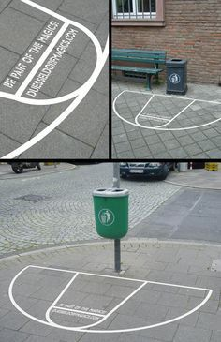

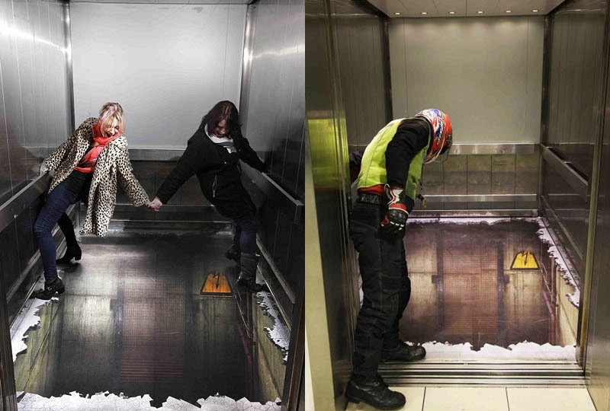

<https://twistedsifter.com/2012/06/funny-creative-floor-sticker-ads/>

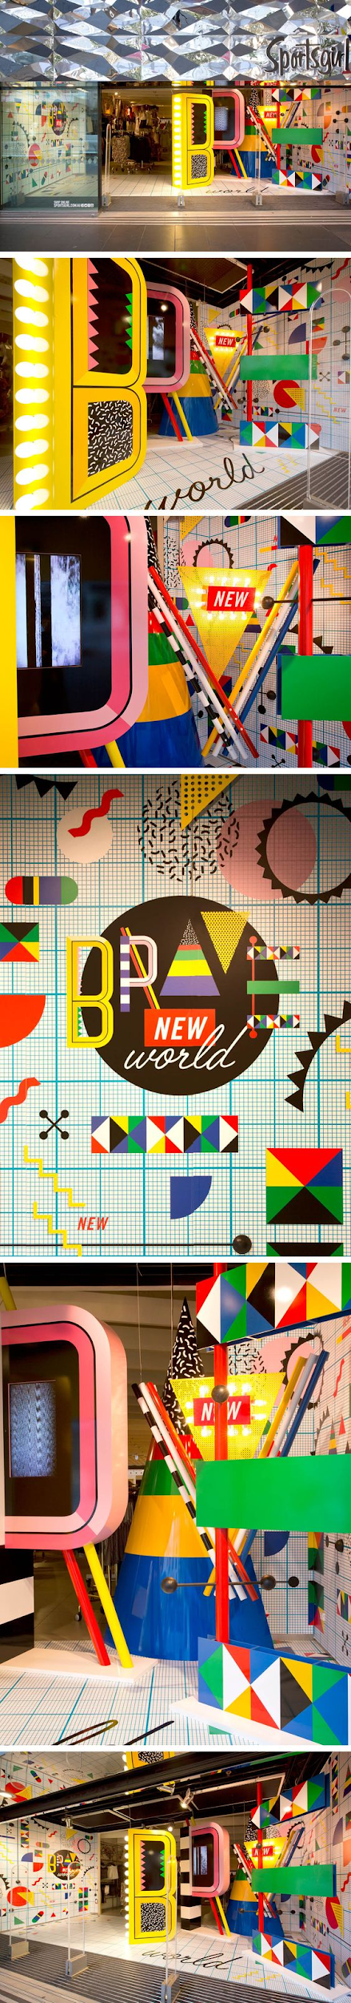

<https://www.pinterest.es/pin/701717185664615309/>

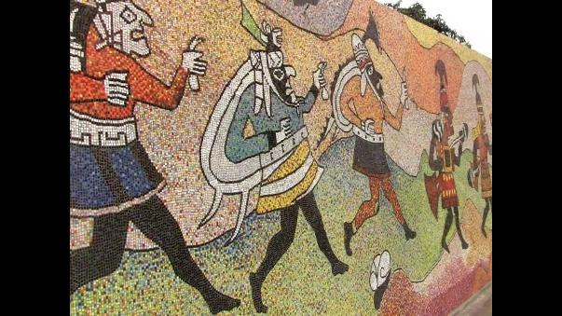

<https://rpp.pe/peru/actualidad/el-inigualable-mural-de-mosaicos-de-trujillo-noticia-547405>

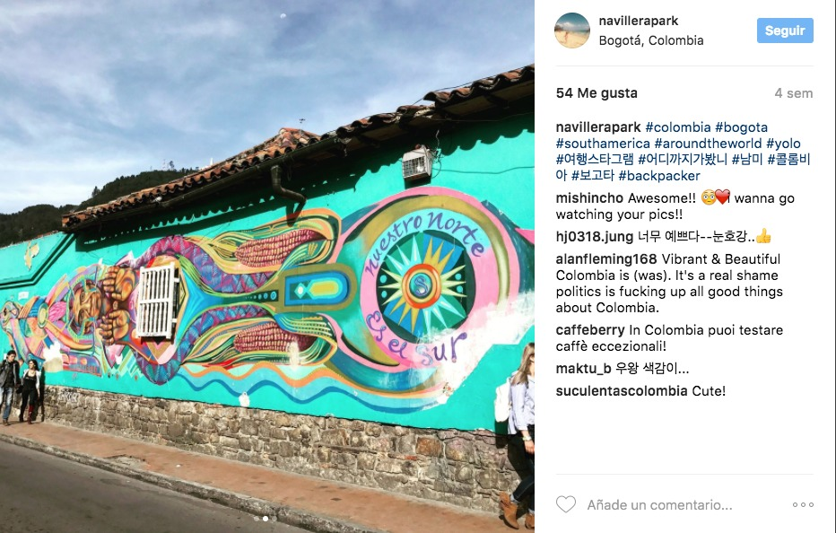

<https://imaginariodejaneiro.com/mural-mas-grande-del-mundo/>



<https://imaginariodejaneiro.com/mural-mas-grande-del-mundo/>

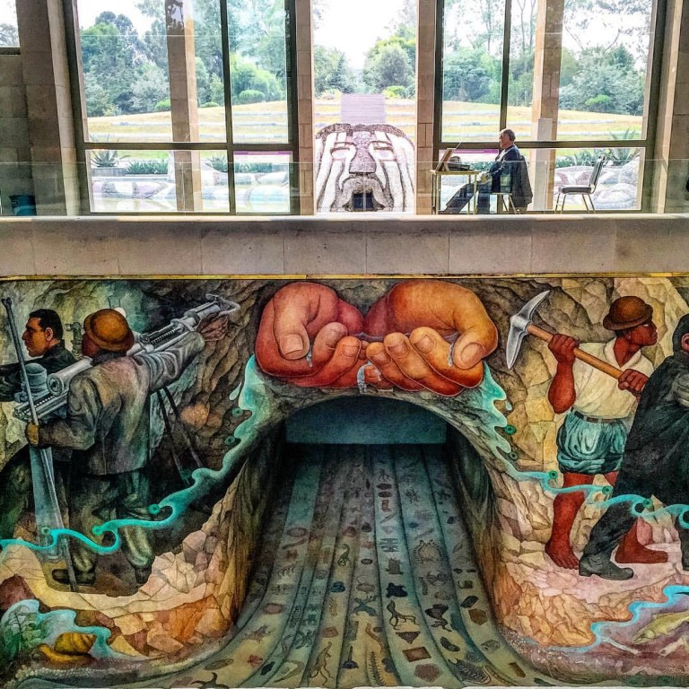

<https://mxcity.mx/2016/09/7-mas-hermosos-murales-de-la-ciudad/>

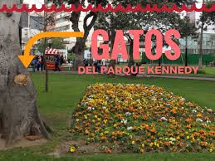

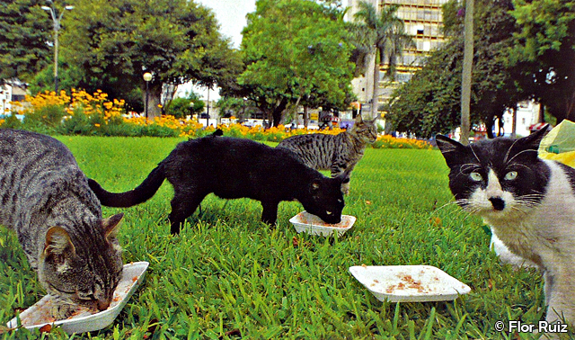

<https://viajandoalima.com/parque-kennedy/>

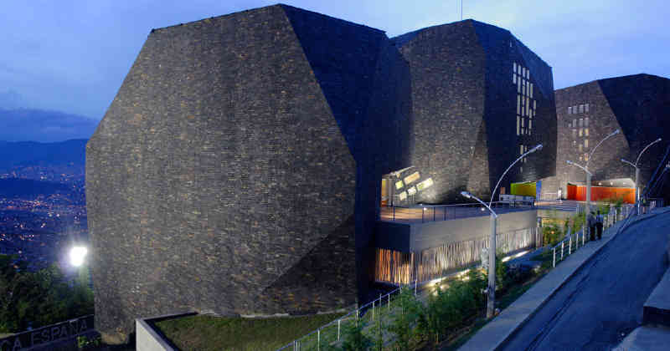

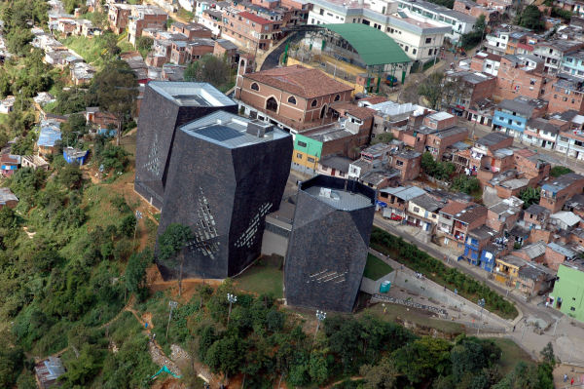

<https://www.archdaily.co/co/02-6075/biblioteca-parque-espana-giancarlo-mazzanti>

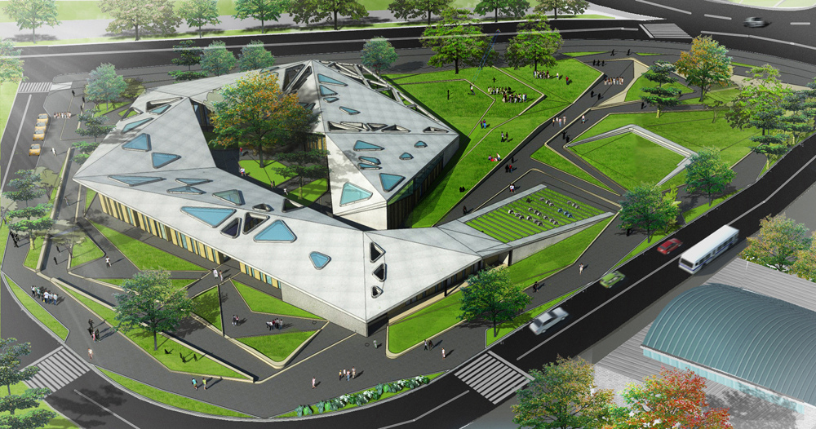

<https://www.flickr.com/photos/microcadltda/5266362166>

**Branding**

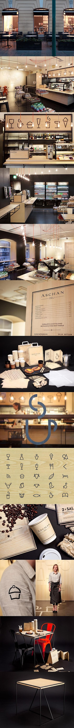

<http://mhou.es/ideas-de-diseno-para-bares-y-restaurantes/?utm_source=feedburner&utm_medium=feed&utm_campaign=Feed:+blogdemhou+(Blog+de+Mhou)>

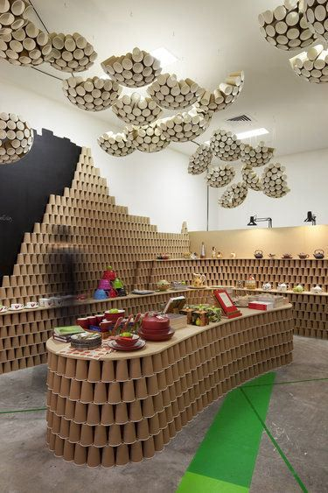

<https://studioescaparatismo.es/2016/01/21/escaparates-con-decoracion-de-carton-eco-chic/>

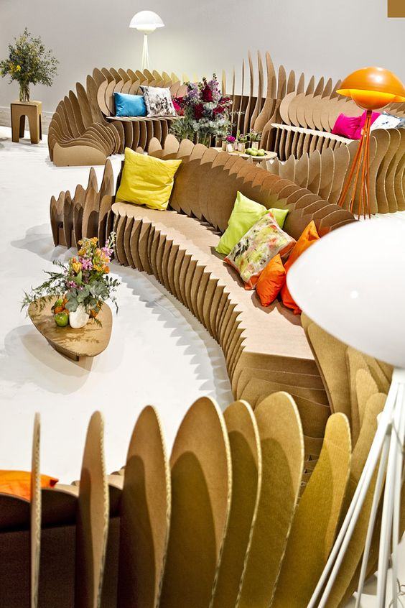

<http://decorationdigest.com/blog/2013/03/13/muebles-de-carton-fun-una-creacion-y-diseno-de-sanchez-garrido-arquitectos/>

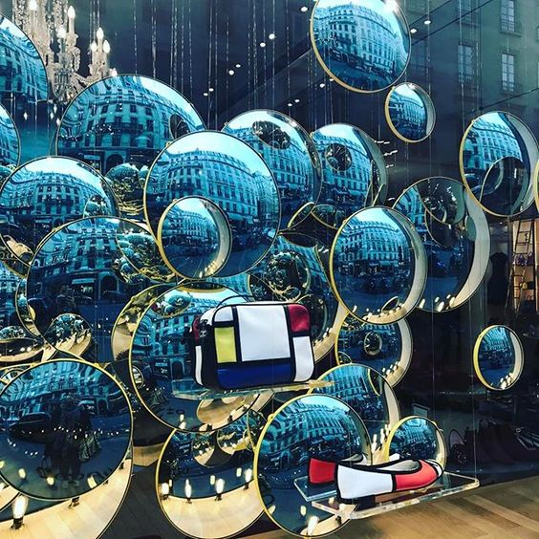

<https://www.pinterest.es/pin/384494886926993262/>

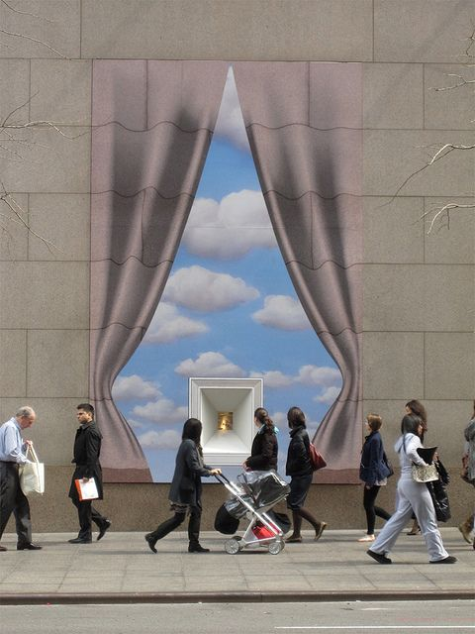

<https://www.pinterest.es/pin/568227677968895610/>

<https://es.paperblog.com/escaparates-tiffany-el-envoltorio-es-tan-importante-como-el-regalo-1465772/>

**Referentes estilo ilustración y gráfica**

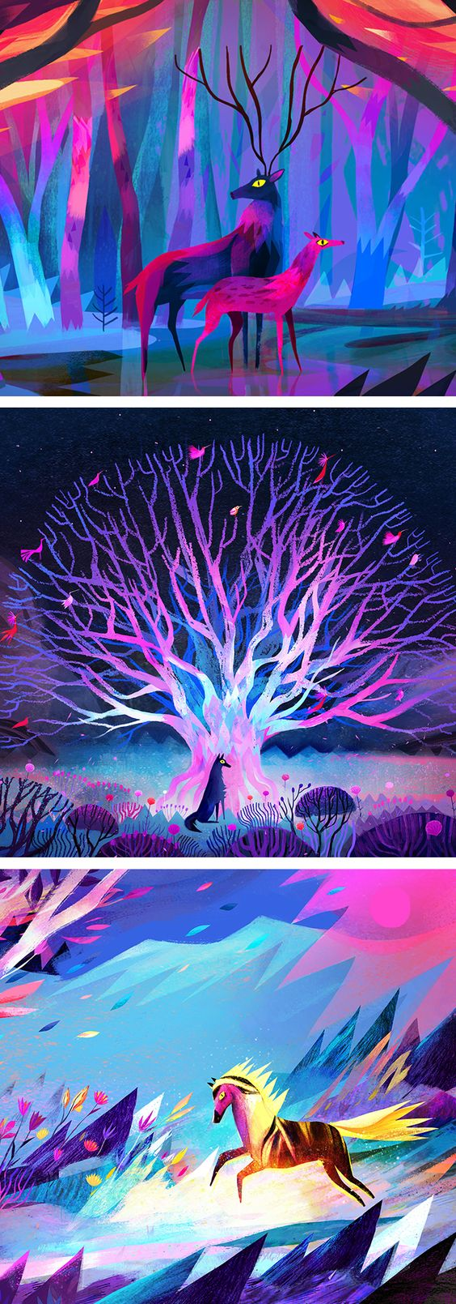

<https://www.brwnpaperbag.com/2017/12/04/concept-art-juliette-oberndorfer/>



<https://www.pinterest.es/pin/582442164279120767/>

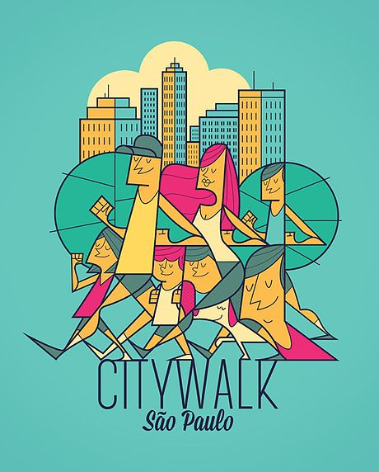

<https://www.alegiorgini.com/citywalk>



<https://www.behance.net/gallery/19074843/Gustolato-ice-cream>

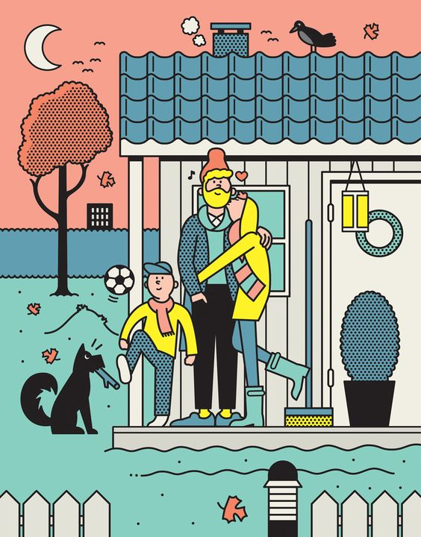

<https://www.oldskull.net/ilustracion/las-divertidisimas-ilustraciones-de-rami-niemi/>

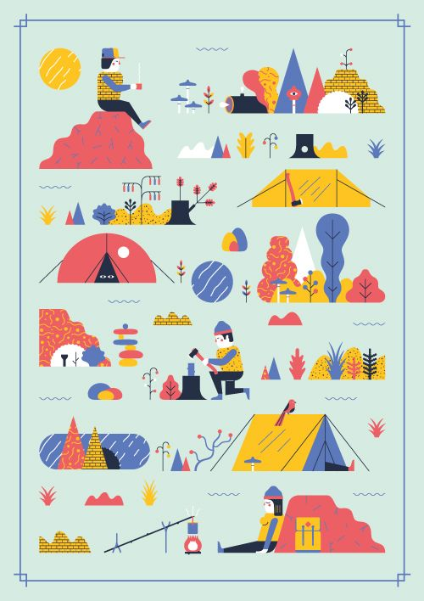

<https://www.pinterest.es/pin/51509989472328323/>

<https://www.google.com.ar/search?q=mapas+ilustrados&client=firefox-b-ab&tbm=isch&tbs=rimg:CTvigvSVS4vlIjiMNmO6NGJTNA0gvBfvs3VDNHxcqTu--lJseFy7dUbItloEFA-p5fq25byDXQvDDEteqIuqj2ZQmyoSCYw2Y7o0YlM0EQyfNjZ7rRwCKhIJDSC8F--zdUMR9Rp0xyRIVGEqEgk0fFypO776UhGMTZCPt83rZioSCWx4XLt1Rsi2EUFCj3Hv6HOzKhIJWgQUD6nl-rYRIF1mXtpvxzUqEgnlvINdC8MMSxFwCIaoSRYUryoSCV6oi6qPZlCbEYFYqc2eGZZo&tbo=u&sa=X&ved=0ahUKEwil09KR-PzUAhWME5AKHVeyD_0Q9C8IHw&biw=1164&bih=544&dpr=1.1#imgdii=bi30YN-fC6tPeM:&imgrc=vJf_6g7fkm7ezM>:

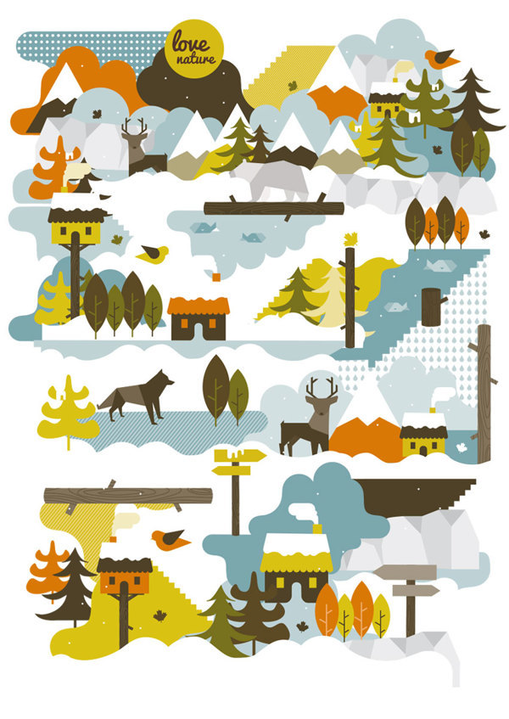

<https://mundanalconsumo.tumblr.com/post/64776301260/visualgraphc-love-nature-neosbrand-la>

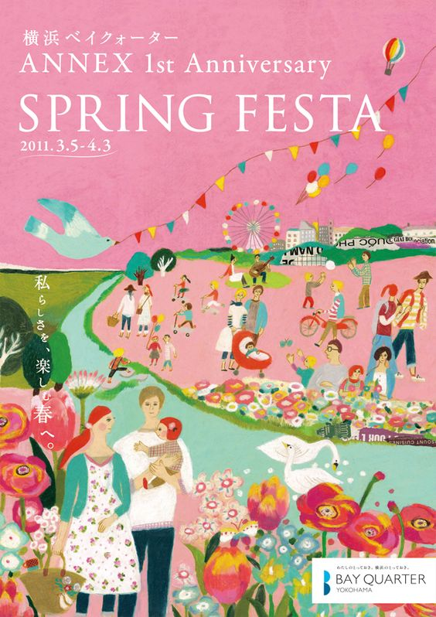

[http://www.shibata-illust.com/works-category/advertisement/page/3/#!prettyPhoto[gallery]/11/](http://www.shibata-illust.com/works-category/advertisement/page/3/#!prettyPhoto%5Bgallery%5D/11/)

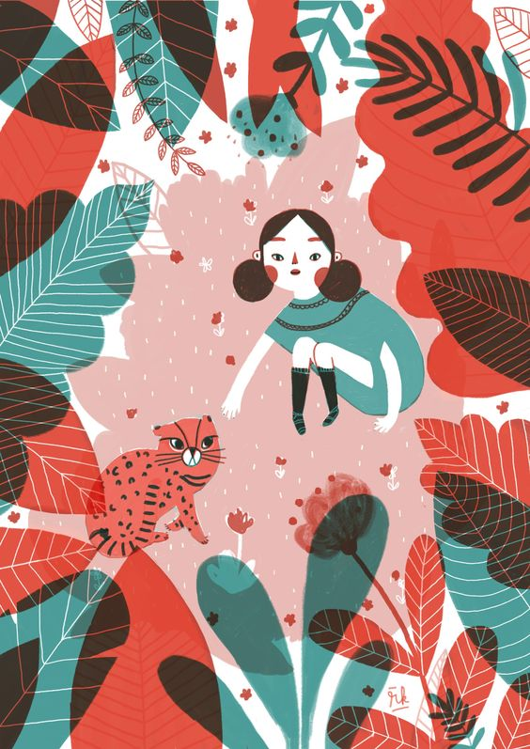

<http://notanotherfashionblog.es/rachel-katstaller-ilustrar-es-mi-pasion/>



<https://www.behance.net/gallery/27306711/Summer>



<https://www.pinterest.es/pin/444237950729296624/>



<https://www.pinterest.es/pin/214061788522810793/>

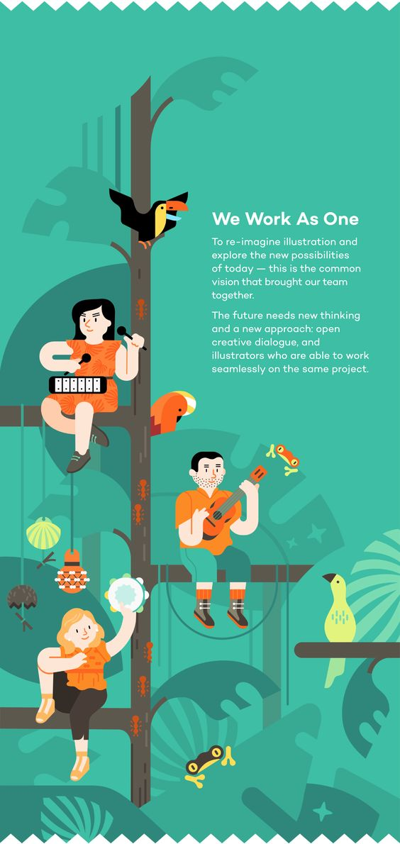

<https://www.behance.net/gallery/18573067/MV-Self-Presentation>

Concepto importante: Wayfinding